Dependencies metrics

Class metrics

Cyclic

Calculates the number of classes or interfaces which each class directly or indirectly depends on, and which in turn directly or indirectly depend on it. Such cyclic dependencies may result in code which is difficult to understand and test.

There is no cyclic dependencies, so there isn’t any type of difficult code to understand so that means there isn´t probably any long method code smell.

Distribution of dependencies by class

Calculates the number of classes or interfaces which each class directly depends on.

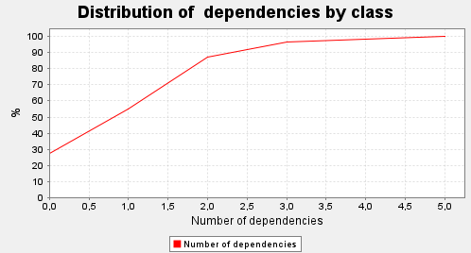

The graph shows us that 30% of the classes dont depend on any class, most likely super classes or god classes.

Distribution of dependents by class

Calculates the number of classes or interfaces which directly depend on each class.

Most likely the same situation from the distribution of dependencies by class where the project uses a lot of god classes, since 80% of the classes have 0 dependents.

Package metrics

For the 3 metrics above the package metrics has similar values, so we can conclude the same because the classes need to be inside the packages.